YOU’LL LIKE YOUR MAGAZINE!
FREE With AICA Membership – Charolais Journal magazine has provided the Charolais industry’s most important decision makers with the information on topics related to their business and personal lives. Designed to give readers a broader picture of our industry and the products and services therein, the Journal has become another tool to assist our readers in their purchasing decisions. Because we want to give our readers and advertisers the best possible service, we’ve listened to your comments and suggestions, and we will bring you a magazine we know you will like!
SHARP ANALYSIS. The Charolais Journal contains topics carefully selected to provide you with current cattle industry information. By offering our readers more valuable information, they stay with the product (and your ad) even longer.
EDITORIAL CONTENT.
Editorial content includes sale reports, shows, and special features relevant to national
Charolais activities as well as regional events. It’s your best source for news of the industry.
SPECIAL ISSUES:
January – Bull Buyers Guide Issue
June/July – Directory & Membership Issue
August – Junior Issue
September – Commercial Issue
SUBSCRIPTION RATES: U.S. - $100 U.S. First Class - $125
First Class Foreign - $175 – U.S Funds Only Foreign - $125 – U.S. Funds Only
- CHECK (Payable to Charolais Journal)
- VISA or Mastercard (Circle One)
Name on Card: ______________________________________________

CARD # _____________________________________________________

Exp. Date: ___________________________________________________

Signature: ___________________________________________________

Address: _____________________________________________________

City: ____________________State: ___________________ZIP: ________

Mail to:
American-International Charolais Association
11700 NW Plaza Circle, Kansas City, Missouri 64153

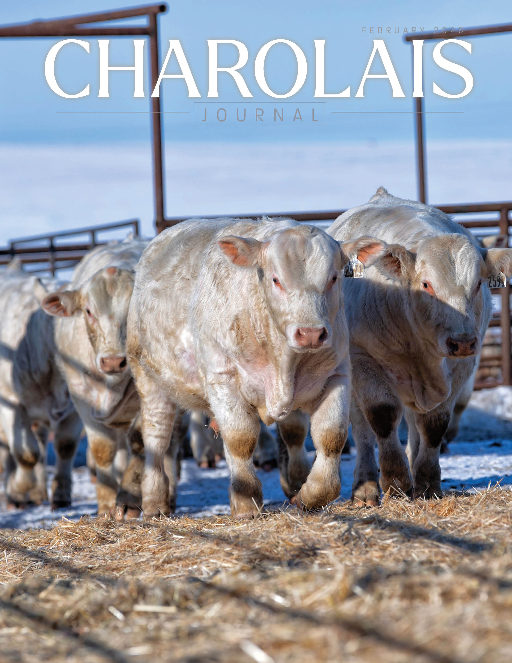
YOU’LL LIKE YOUR MAGAZINE! Subscription Form on Back

